Meta Title:
Expert Residential & Commercial Painting Services in Houston
Meta Description:
Looking for superior house painting services near Houston? Trust Houston Custom Carpets for expert painting solutions suited to your needs.

https://houstoncustomcarpets.com/services/painting-houston/ | painting services Houston | 30
 | Houston Painting contractor | 40
 | house painter near me | 8.1k
 | house painter | 9.9k
 | painting in Houston | 140
 | Best Painter | 390
 | Painter services | 170
 | commercial painting contractors Houston tx | 390
 | Interior Painting Services | 1k
 | exterior Painting Services | 880
 | Cabinet painting | 14.8k
 | best painters near me | 1.3k


Painting Services Houston (h1)

Discover the Beauty of Precision With Our Painting Services in Houston (H2)
Give your home or office a new look with the best painting services in Houston. With the help of our professional staff, we guarantee to give life to your place while providing the best finishing touch possible. At Houston Custom Carpets, we will revamp your space in your style with the use of cutting-edge tools.

Consult Now

Meet the Top Rated Painting Agency in Houston (H2)

All the painting services provided at Houston Custom Carpets are aimed to meet your needs and requirements as per your style and preference. Our team of Houston Painting contractors is not only qualified but have all the necessary resources and tools needed to complete any task with precision and perfection. Moreover, our experts are very qualified in terms of experience and skills which is the main reason why we are the best painters near me in Houston. Additionally, customer satisfaction is our core goal and our expert painters will do anything to meet even exceed their expectations.

Don't Let the Outdated Paint Steal the Charm (H2)

When your paint is old and flaking, the room looks dull and less inviting. Transform your property with our outstanding painting services in Houston. Here at Houston Custom Carpets, we respect the specific characteristics of all individual spaces. This is why we make various plans that help our house painters meet the customer's needs and the overall appearance they wish for their property. We have a very experienced team and we utilize new techniques as well as different finishes such as modern traditional and textured. Let us beautify your space, and the world around you, to make every spot in your home or office unique. It is possible to have a new, enjoyable, and clean look with Houston Custom Carpets. Come and talk to us today and let us transform your space.

Explore Our Premier Painting Services in the Houston Area (H2)
If you are searching for the best house painter near me agency in Houston then look no further than Houston Custom Carpets. Our company is the one-stop solution for all your needs ranging from residential painting to commercial painting services.

Residential Painting | Cabinet Painting
Being a residential painting company in Texas we understand your home’s requirements and provide a fitting solution. From repainting an entire house to applying new coats of paint on a wall or two we offer the best service. Together we determine how the living space should look and feel, we choose the best colors and materials for your home. | Improve the appearance and market value of your home by hiring our cabinet painters in Houston. Our experienced painters can paint your kitchen or bathroom cabinets and breathe new life into your cabinets. It’s important for your cabinets to not only be aesthetically pleasing but also long-lasting; we provide both color change and refinishing.
Exterior Painting | Interior Painting
First impressions are always considered as the last time, and if the exterior part of your building is what captivates the onlooker, then we are here to help. Our expert painters grasp the significance of a robust external painting. That's why we offer exterior Painting Services to increase the home's beauty and add some extra value to the house. | We offer the best Interior Painting Services in Houston with the aim of transforming your homes and offices into something stylish and cozy. Through attention to detail and color theory, our professional painters design proper and appealing-looking rooms. Select from our wide range of options or let us offer you beautiful options concerning color combination and texture.
Commercial Painting | Front Door Painting
The first impression matters a lot in the world of business, and it is through our commercial painting contractors in Houston TX that can help you get the best. Our commercial painting services include Color Consultation, Surface Preparation, Paint Application, and punctuality when handling office, retail, and other commercial painting services. | Your front door is the first area that a guest would come across when entering your compound, therefore it must leave a good impression of the entire compound. Here, at our Houston front door painting services, we bring out the property’s individuality and personality. Based on our experience we guarantee to make your home more appealing.

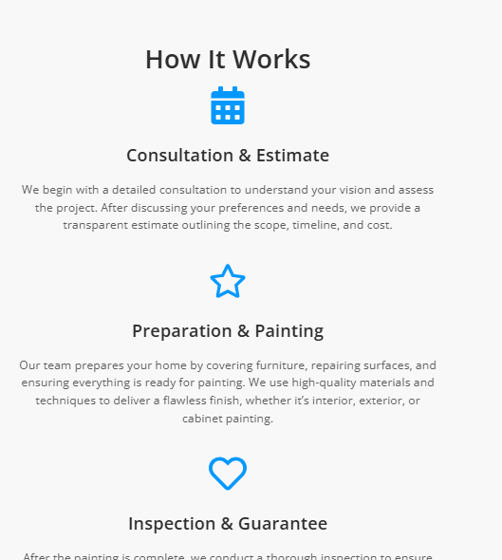

How Does Our Painting Process Exactly Work?

Consultation | Custom Quotes | Scheduling
Our Painter services start with the consultation of our painting needs, the designs we want, and the outcomes we expect. The team here at Ourteamelistens to your vision and provides professional guidance that you can rely on. | Based on each conversation we present a highly specific and individual price estimate, which contains the cost of services we will offer, the materials we will use, and the overall timeframe of the project in hand. | Once you endorse our quote, a schedule is set for your painting project depending on your availability. Specifically, the working of our team does not interfere and causes little or no other kind of inconvenience.
Preparation | Painting | Final Walkthrough
Our painters make sure that your property is well-prepared for painting. In this process, we cover all areas of floor and furniture, fix any required area, and ensure the safety of the property from drops of paint. | We pride ourselves in having the experts who have the ability to turn your ideas into reality. All our experts work very hard and fast with proper cleaning and ordering of tools used throughout the project’s duration. | Upon the completion of the painting, we take you around the house to make you see everything that has been painted. We care about your happiness and can come back to make any refinements if needed to ensure you are satisfied.

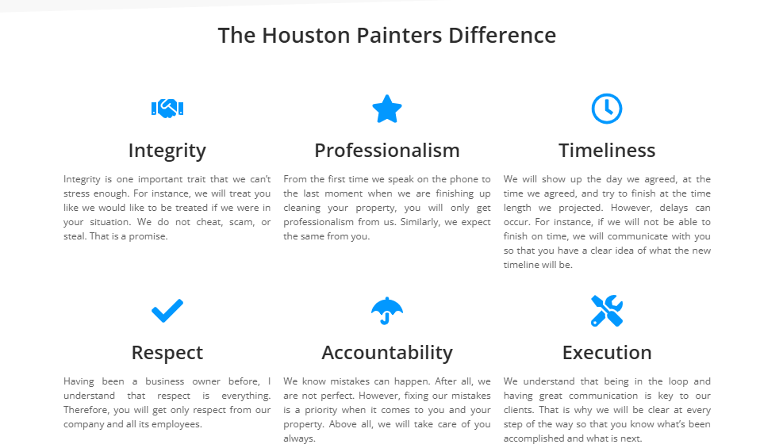

Feel the Difference with Houston Custom Carpets (H2)
If you want to work with a competent and experienced painting agency then look no further than Houston Custom Carpets. Here are six reasons to choose us for your needs related to painting in Houston:

Quality work | Professional service | Personalized approach
At our company, our experienced painters are proud to give the best work done by them. At our facilities, we only employ premium resources and the latest approaches to deliver perfect and durable paintwork for all your needs. | This is where our firm stands out in the provision of reliable and efficient service. Ensuring that your project is finished on time is our main priority, so our team will do everything possible to keep that promise with you. | At Houston Custom Carpets, we understand your vision and personal preferences providing you with the best services. Our team takes time to understand your needs more accurately with a guarantee to provide the best quality paint job.
Customer satisfaction | Competitive Pricing | Convenient scheduling
We provide you with complete satisfaction for your business needs. If you have any questions, or concerns, or need advice on the maintenance of the facilities our team is always ready to assist you in matters related to the paint job. | At Houston Custom Carpets, you are supported by our flexibility to offer the best painting services at friendly costs. We prepare a specific and detailed quotation and try to explain our costs so that you can agree with us directly. | We have a flexible appointment schedule and provide consultations, painting, and a final walk-through at your convenience. Our expert team of the best painters always takes pride in our practices to help our customers even after the job is done.

FAQ's

How long it will take to complete a painting project? (H3)
The time taken to complete a painting job depends on the scale of the project in terms of size. We include an estimated timeline in your free quote, so you are aware of the duration of time in the process of task completion.

Would you advise your clients on the right color choices? (H3)
Of course, we provide color consulting services. Having a team of dedicated painters, our company can suggest the right hue and texture that will complement your dream.

What if I am dissatisfied with the final outcomes? (H3)
If you are not satisfied with the quality of the final work, the team will not hesitate to resolve your issue. Moreover, we will gladly make any further refinements as required to ensure you are fully happy with our painting work.

Is it necessary for me to stay when you are painting? (H3)
It is not prohibited to be present during the painting process, and we strongly encourage you to attend this process. This makes certain that we are fully aware of your preference, and if there are any variations that need to be made in that course, it will be easily achieved.

Do you offer exterior and interior painting services? (H3)
Yes, we provide all-encompassing painting services for your interior and exterior spaces. Our painters are professional and will ensure that your inside and outside space is painted up to the mark.

Are you licensed and insured? (H3)
Yes, Houston Custom Carpets is absolutely legal and we have all the licenses and insurance needed.

